SpaceX Launch Records Dashboard
Submitted By
Name: Nidhi Kumari
Course: Master of Computer Applications (MCA)
Semester: 4th Semester
University: Manipal University Jaipur

SpaceX Launch Records Dashboard using Plotly Dash
1. Introduction
Data visualization plays a significant role in understanding large datasets and extracting useful insights. Interactive dashboards enable users to explore information dynamically by filtering and visualizing data from different perspectives. Plotly Dash is a Python framework that allows developers to create analytical web applications without requiring JavaScript.
In this project, an interactive dashboard was developed using the SpaceX launch dataset. The dashboard provides different visualization components that allow users to analyze launch success rates, payload distribution, launch site performance, and booster performance.
The dashboard consists of four major tasks including a launch site dropdown, a success pie chart, a payload range slider, and a scatter plot for payload analysis.

2. Project Objectives
The objectives of this project are:
- To develop an interactive dashboard using Plotly Dash.
- To visualize SpaceX launch records.
- To compare launch success across launch sites.
- To analyze the relationship between payload mass and launch success.
- To provide interactive filtering using Dash callbacks.

3. Software and Technologies Used
The following tools were used during implementation:
- Python 3
- Pandas
- Plotly Express
- Dash Framework
- Visual Studio Code
- IBM Skills Network Cloud IDE

4. Dataset Description
The SpaceX launch dataset contains historical launch information including launch sites, payload mass, orbit, booster version, and mission outcome.
Important columns used in the dashboard include:
- Launch Site
- Payload Mass (kg)
- Booster Version Category
- Class (Launch Success)
The Class column indicates whether a launch was successful.
- 1 = Successful Launch
- 0 = Failed Launch

5. Dashboard Implementation
Task 1 – Launch Site Dropdown
A dynamic dropdown menu was created to allow users to select launch sites.
Features:
- Displays all available launch sites.
- Default option is "All Sites".
- Searchable dropdown.
- Populated dynamically using the dataset.
Output
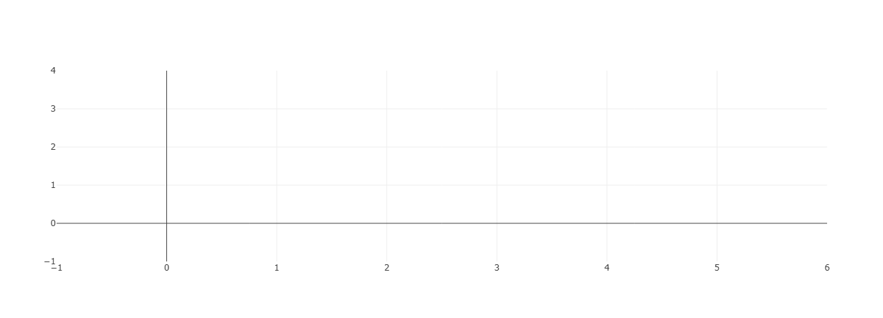
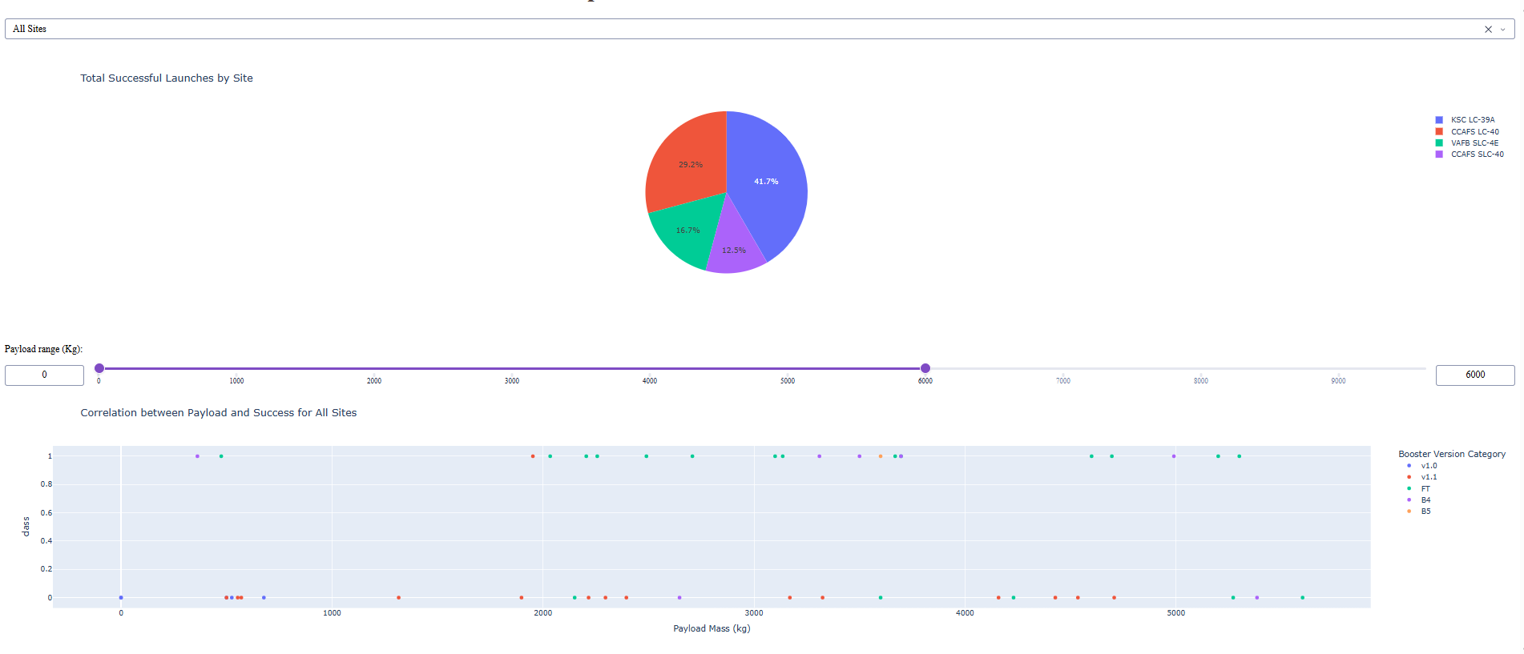
Explanation
The dropdown improves dashboard usability by allowing users to filter visualizations according to a selected launch site. When "All Sites" is selected, the dashboard displays overall launch information. Selecting a specific launch site updates all graphs automatically through Dash callbacks.

Task 2 – Success Pie Chart
A callback function was implemented to update the pie chart according to the selected launch site.
When "All Sites" is Selected
The dashboard displays the total number of successful launches for each launch site.
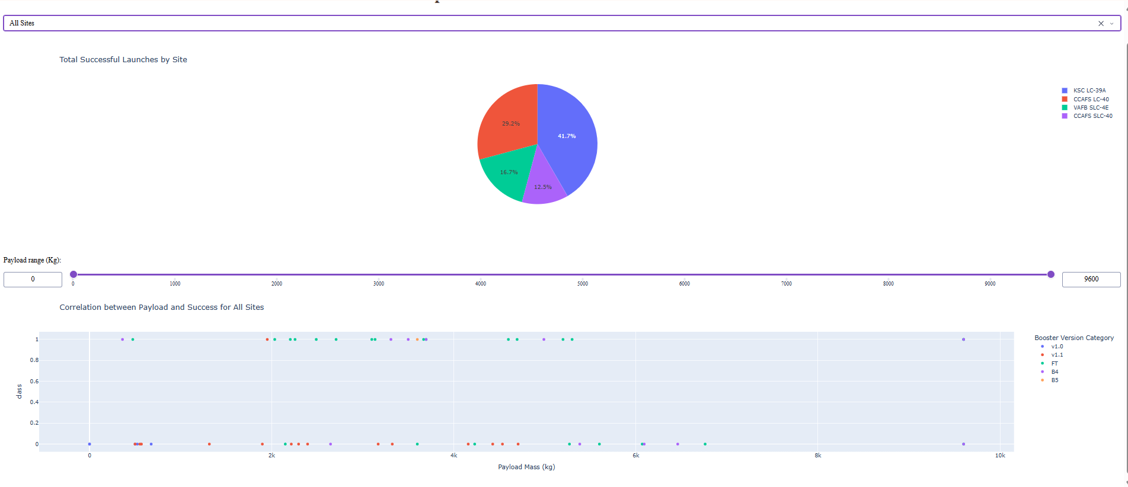
When a Specific Launch Site is Selected
The dashboard displays the number of successful and failed launches for that site.
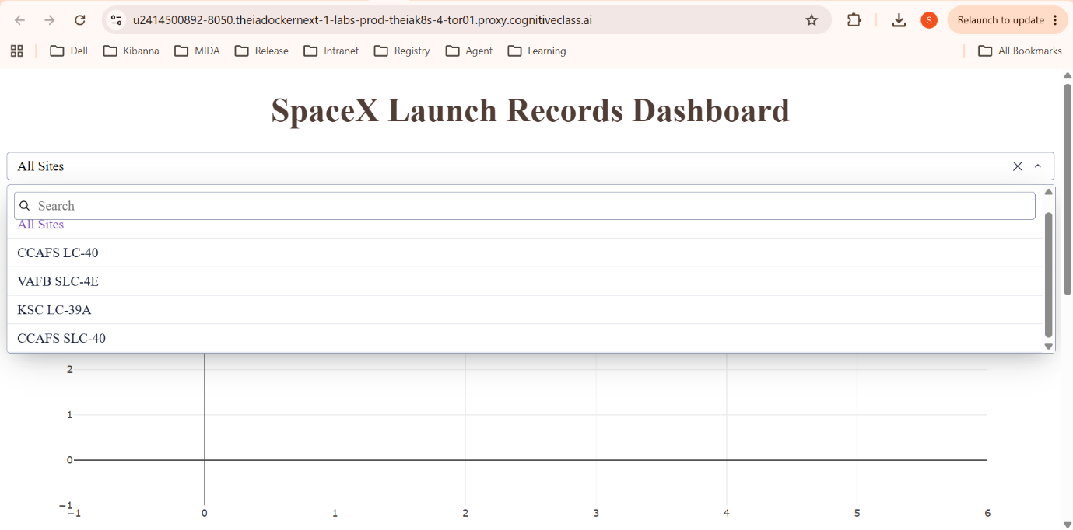
Explanation
The callback filters the dataset based on the selected launch site. Plotly Express generates a pie chart that updates automatically whenever the dropdown selection changes.

Task 3 – Payload Range Slider
A RangeSlider component was added to filter launches according to payload mass.
Features include:
- Adjustable minimum and maximum payload.
- Dynamic filtering.
- Interactive updates.
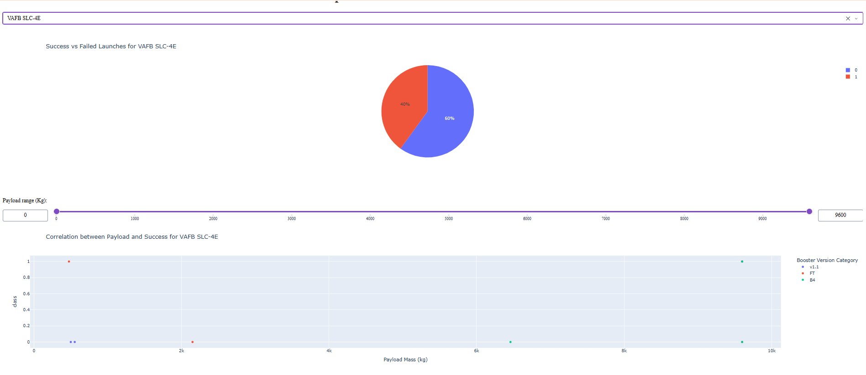
Explanation
The slider allows users to analyze launch performance within a specific payload range instead of considering the entire dataset.

Task 4 – Payload vs Success Scatter Plot
A scatter plot was created to visualize the relationship between payload mass and launch success.
The graph displays:
- Payload Mass on X-axis
- Launch Success on Y-axis
- Booster Version Category using different colors
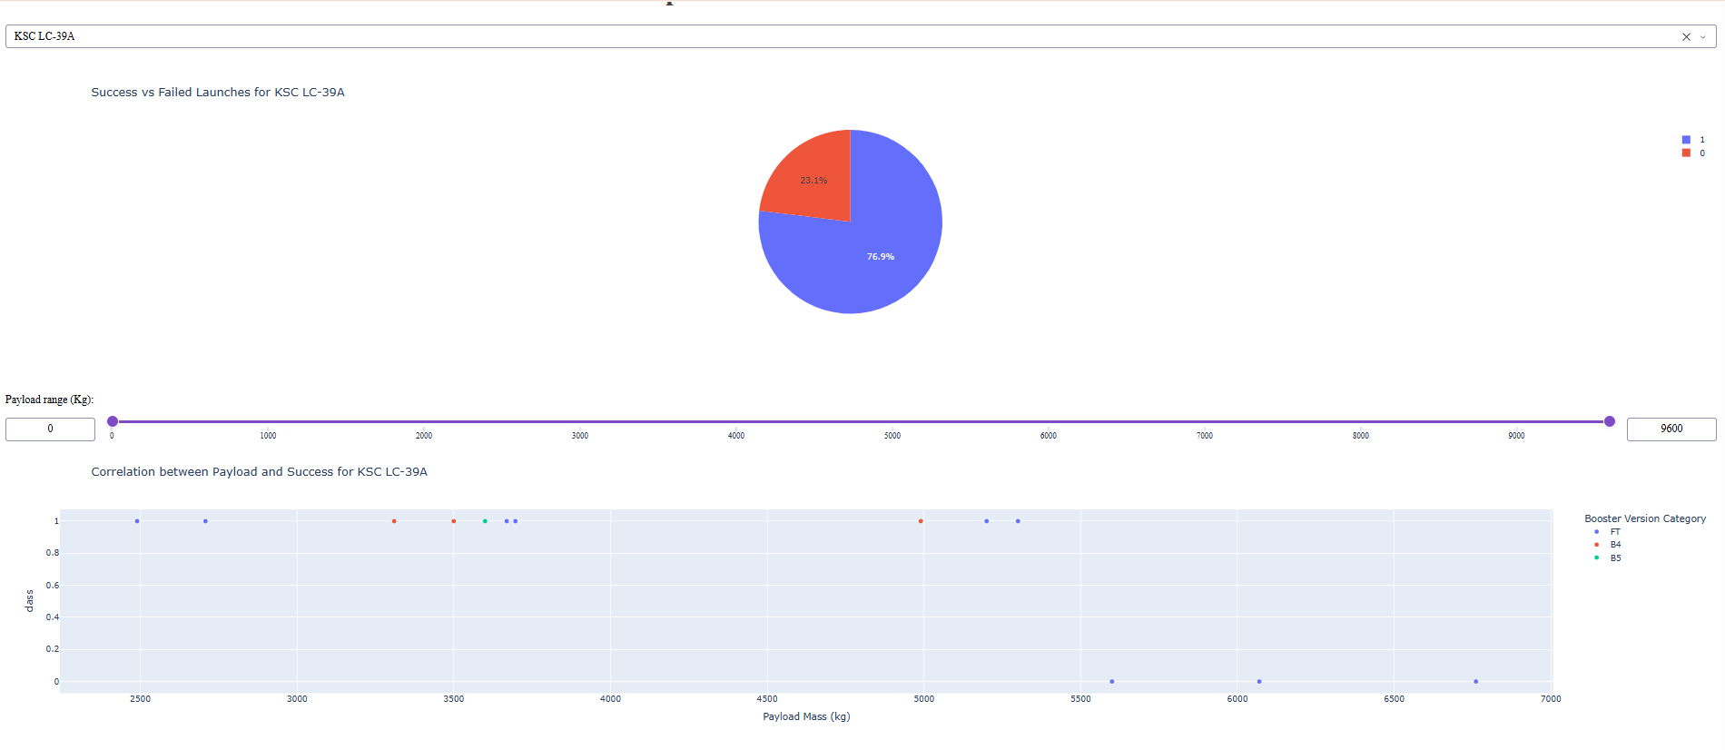
Explanation
The scatter plot updates according to both:
- Launch Site
- Payload Range
This provides better insight into how payload affects launch success across different booster versions.

6. Dashboard Analysis
The dashboard provides several useful observations.
- Launch success varies across launch sites.
- Payload mass influences mission success.
- Booster version categories show different success trends.
- Interactive filtering makes the dashboard suitable for exploratory data analysis.

7. Answers to Dashboard Questions
Question 1
Which launch site has the largest number of successful launches?
Based on the dashboard visualization, KSC LC-39A has one of the largest numbers of successful launches among all launch sites.

Question 2
Which launch site has the highest success rate?
The dashboard indicates that KSC LC-39A demonstrates one of the highest success rates because the majority of launches shown for this site are successful.

Question 3
Which payload range has the highest launch success rate?
The scatter plot suggests that medium to higher payload ranges generally contain more successful launches compared to lower payload ranges.

Question 4
Which payload range has the lowest launch success rate?
Lower payload ranges contain a greater mixture of failed launches, indicating comparatively lower success rates.

Question 5
Which Booster Version Category has the highest success rate?
From the scatter plot, FT appears among the booster version categories with the highest number of successful launches.

8. Challenges Faced
During implementation, several challenges were encountered:
- Understanding Dash callbacks.
- Linking dropdowns with graphs.
- Filtering multiple inputs simultaneously.
- Updating graphs dynamically.
These issues were resolved by using callback functions and Pandas data filtering.

9. Learning Outcomes
Through this project, the following concepts were learned:
- Interactive dashboard development.
- Data visualization using Plotly Express.
- Dash callbacks.
- User interaction using dropdowns and sliders.
- Dynamic filtering of datasets.
- Building analytical web applications using Python.

10. Conclusion
The SpaceX Launch Dashboard successfully demonstrates the capabilities of Plotly Dash for interactive data visualization. The dashboard allows users to explore launch performance, analyze payload effects, compare launch sites, and evaluate booster performance. Interactive components such as dropdown menus, pie charts, sliders, and scatter plots make the dashboard effective for analysing real-world aerospace data. This project strengthened practical knowledge of Python, Dash, and data visualization techniques while demonstrating how interactive dashboards can support analytical decision-making.

